SENATE STUDENT SUCCESS COMMITTEE (SSSC)

MEETING AGENDA
  - MEETING INFORMATION
Date: April 24, 2019 Location: TRUSU Boardroom
Time: 14:00 - 15:30

Co-Chairs: Aria Appleton, Airini
Note taker: Airini

Attendees: Michael Bluhm, Don Poirier, Tanvir Alam, Dipesh Prema, Julia Wells, Judy Duchscher, Carolyn Ives, Airini, Aria Appleton.
Guests: Matthew Kennedy, Alana Hoare
Apologies: Chris Adam, Dorys Crespin-Mueller, Archit Gupta

Quorum was not met. The attendees received reports and deferred business including receiving Minutes (March 2019).

  - MEETING NOTES - Topics
- Acknowledgement of Territory [Aria/ Airini]
The campuses of Thompson Rivers University are located on the traditional and unceded territory of the Secwepemc Nation within Secwepemcul'ecw. As we share teaching, learning and research within this university, we recognize that this territory has always been a place of teaching, learning and research.
- Reports [Aria]
  - Strategic Enrolment Management Initiative (Mike Bluhm) [Airini]
      - Assessment report received from external consultants. Report is with the SEM taskforce. Full report will be published with addendum. Upcoming workshops including May 9 on SEM Core Concepts. Please contact Mike Bluhm if interested in attending.
      - Q/A: Why does SEM matter to this committee? Student Success committee is important as a consultative group.
  - Student Success from an OL perspective (Don Poirier) [Aria]
      - AVP Open Learning provided a presentation on student success in an Open Learning context. Thank you Don for the ppt which will be circulated.
      - Scope of presentation: What does success mean, what we knew, what we know, what we need to know?
      - ‘Open’: is about the reduction of barriers to access to knowledge, e.g. geography; social justice element.
      - Who is defining ‘success’?: Student centred vs Student driven
      - Serving two groups – individual course takers and program takers. ‘Success’ is distinct for each. For program takers OL has served predominantly working mothers – attempting to serve career, community obligations, family. However at program level, the OL students are getting younger: “We can’t claim to know our students!” – career goals, expectations around student services, etc.
      - 2017/18 saw 1400+ dually enrolled students at TRU, a 65% increase since 2013/14. We have to realise that campus students take OL courses and OL students take campus courses. Success will cover both. This is a very fluid area.
      - Academic success factors for adult learners (2011 OL report on course completion): realistic student expectations, understanding of online and distance learning experience, goal orientation, knowledge of individual learning style, availability of targeted support systems, interaction between student and faculty.
      - Success factors identified by OL: PLAR – recognising prior learning and leverage from this; treat learners as adults (andragogy v pedagogy)
      - 5 factors for successful online learning (PPIC): Use a systems approach to course design, provide professional development, set student expectations, create community take advantage of online environment.
      - OL performance (2019): Course completion including withdrawals: 60%; course completion total: 80%
      - From student consultation the top factors affecting success are: Preferred communication: e-mail; Goals: professional/ personal; Challenges: time; Positive experiences: OLFMs; Negative experiences: communication; Valuable about OL: flexibility.
      - ‘Student success’ redefined: See the student success stories at TRU-OL – recognition of who they are personally and academically, acceptance (transfer credit, PLAR), respect, each other.
      - ‘Success’ can be rare (recognition, acceptance, respect, everyone) and done (determined, open to change, nuanced, everyone, as in ‘for every TRU student’)
      - Q/A: (a) What about OL for students without access to internet or computers?: TRU is legislated to meet the Open Learning needs of the Province. Therefore we have to be prepared to print off course materials for those without access to technology. (b) From student caucus OL comes up a lot. OL students don’t get the same access to their tutor as if in the classroom. Your thoughts?: Equitable does not mean equal. It’s not an equal support. What we are seeing is a convergence of all students – access to mental health, financial support, student services. It is about understanding the needs of the students – whether on-campus or OL.
  - Standing Committee Report to Senate [Airini]
Report from Matthew Kennedy on SSSC Terms of Reference: “To advise the Accreditation Steering Committee and report on mission fulfilment in relation to the core theme Student Success.”
Thank you Matthew for the ppt presentation:
      - background
      - mission fulfilment framework
      - mission fulfilment reporting
Background: Student Success has been identified as one of the Core Themes for the MWCCU Accreditation. TRU has now embedded this activity in Senate subcommittees, hence: SSSC Terms of Reference includes: “To advise the Accreditation Steering Committee and report on mission fulfilment in relation to the core theme Student Success.”
Mission fulfilment framework:
Mission: TRU is a comprehensive, learner-centred, environmentally responsible institution that serves its regional, national, and international learners and their communities through high quality and flexible education, training, research and scholarship.
Framework: Objectives, outcomes, indicators and mission fulfilment ranges
Achieved for a year when for each of core themes 70% of indicators achieved.
The goals, outcomes, indicators and objectives are set by TRU and able to be changed. We are seeking stretch goals.
SSSC task: Core Theme teams go through the review process which results in a TRU Mission Fulfilment Report:
      - Assessment: how did we do? Did we achieve our mission in relation to indicators, core themes and overall?
      - Gather the values of the indicator
      - compare
      - Planning: What indicators do we need? What Mission Fulfilment Ranges? What are our plans?
      - Are we measuring outputs or outcomes?
      - Is the rationale for the indicator robust?
      - Are there other indicators we should consider in the future?
      - Are the objectives still the right ones
      - Reset mission fulfilment ranges?
      - What can be done to ensure the indicators are achieved?
Reporting need:
        - put together a report which documents assessment and planning process
        - needs to be detailed, demonstrating the discussion and reasons changes to any
        - identify limitations
Accreditation TRU Office timeline for SSSC and others:
      - Assessment by Core Themes (SSSC): May – June
      - July: Compiliation of core theme reports (Accreditation TRU Office)
      - August: Report circulated.
Actions for SSSC
        - Accreditation TRU Office: populate 2018/19 data and past three years into reporting template. Send to SSSC Co-Chairs by 8 May
        - Circulate to SSSC members assigning areas to be reviewed
        - Review comments back from SSSC members by 14 May
        - Draft report included in agenda papers for 22 May meeting
        - SSSC meeting 22 May: Intense review draft report.
        - SSSC meeting 26 June: Approve core theme report for Student Success

- Next Meeting: May 22, 2019 – TRUSU Boardroom [Aria]
Agenda items will include:
      - Approval of March 2019 Committee meeting minutes
      - Review of draft core theme report for Student Success
      - Development of Student Success Committee Workplan: [Airini]
      - Summary of definitions of ‘student success’: Revisiting ideas shared at March 2019 meeting. [Airini]
      - Preparation for working groups to “explore specific aspects of student success (e.g. transition and retention)”, “activities that will foster and promote student success across the University”, and current student success initiatives across TRU (SSSC Terms of Reference 2, 3) [Aria]
Proposed questions:
        - Please identify specific aspects of student success (e.g. transition and retention)” that are going well in your Faculty/Division
        - Please identify specific aspects of student success (e.g. transition and retention)” that are challenges in your Faculty/Division
        - Please describe any specific targets your Faculty/Division has set to advance student success (e.g. x% increase in retention in X program by 2020)
        - Please describe current student success initiatives underway in your Faculty/Division
        - Please describe suggestions you have for activities that will foster and promote student success in your Faculty/Division and/or across the University.

- Adjournment [Airini]

APPENDIX A: Student Success at TRU
TRU Strategic Priorities (5) (https://www.tru.ca/__shared/assets/2014-2019_StrategicPriorities_PDF31428.pdf)
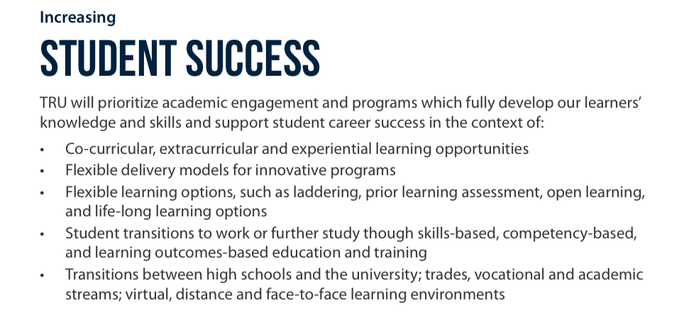
      - Group reporting on ‘4-3-2-1’ exercise (4 students, 3 graduates, 2 co-workers, 1 (yourself): Definitions of ‘student success’) [Airini]
      - TRUSU perspectives on key factors affecting student success [Archit]
      - Current TRU committees and their relationship to student success [Aria]
      - Summary of definitions of ‘student success’ [Airini, with thanks to TRU Library for assistance]
      - EDSW Accreditation – Mission Fulfilment statement – Student Success [Airini]
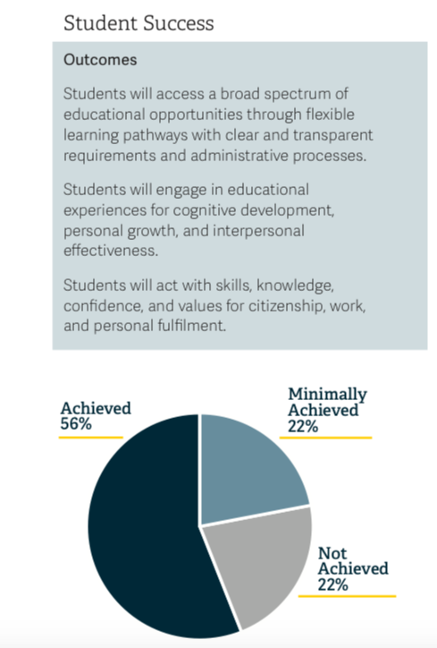

APPENDIX B:

Student Success Committee of Senate - Terms of Reference

Responsibilities of the Student Success Committee:
- To review and report to Senate on studies and research initiatives associated with Student Success that can assist the university in achieving the goals outlined in the University Strategic Priorities and the Academic Plan.
- To recommend activities that will foster and promote student success across the University.
- To develop working groups to explore specific aspects of student success (e.g. transition and retention).
- To advise Senate on policies related to student support and services.
- To advise Faculties, Schools and the Senate on opportunities to foster and enhance linkages between student support activities, academic programs and learning outcomes.
- To advise the Accreditation Steering Committee and report on mission fulfillment in relation to the core theme Student Success.

Composition
- Chair: A Committee member elected by the Committee
- Associate Vice-President, Strategic Enrolment and University Registrar (or
- designate)
- Associate Vice-President, Open Learning (or designate)
- Dean of Students
- Director, Centre for Excellence in Learning and Teaching (CELT)
- Director, Integrated Planning and Effectiveness (or designate)
- Executive Director, Aboriginal Education (or designate)
- Associate Vice-President, TRU World (or designate)
- One Dean
- University Librarian (or designate)
- Two CELT representatives, appointed by the Director
- One representative appointed by the Alumni Association
- Four (4) Faculty and/or Open Learning Faculty Members appointed by Senate
- Up to seven (7) Students nominated by TRUSU and appointed by the Senate
- Steering Committee
  - Secretarial Support: Office of Dean of Students

Ex Officio Non-Voting Members:
- Accreditation Liaison Officer

