Step-by-Step Instructions for
Submitting an Human Research Ethics Application in Romeo

Follow this link to create your account in Romeo: Romeo Research Portal

To submit a new application form:
- Log into your account
- Click on Apply New in the top-right corner of your screen

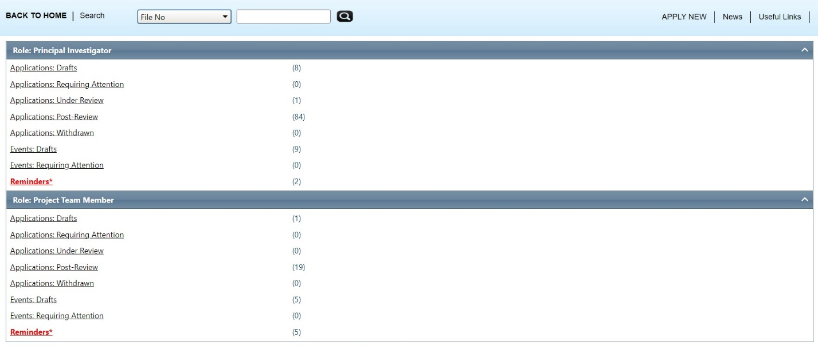

- Click on the appropriate application form

  - Most of the time you will need to complete the form called: 2024 – Human Research Ethics – Application Form
  - Classroom project form is for TRU professors to complete when:
    - A class assignment requires students to collect data from people in the community. This includes anyone and everyone outside the classroom. Data collection includes:
      - Interviews, surveys, focus groups
      - Writing about or taking notes from observations of people
      - Making any kind of contact with people outside of the classroom

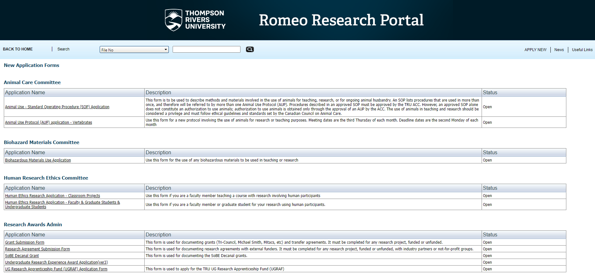

- Go through the first three tabs and answer all the questions.
- The fourth tab, Attachments, is where you can attach:
    - TCPS2 certificate(s)
    - Consent form
    - Data collection tools such as surveys
    - Letter of support from partners
    - Recruitment materials
- The errors tab on the right will inform you of anything that you missed.
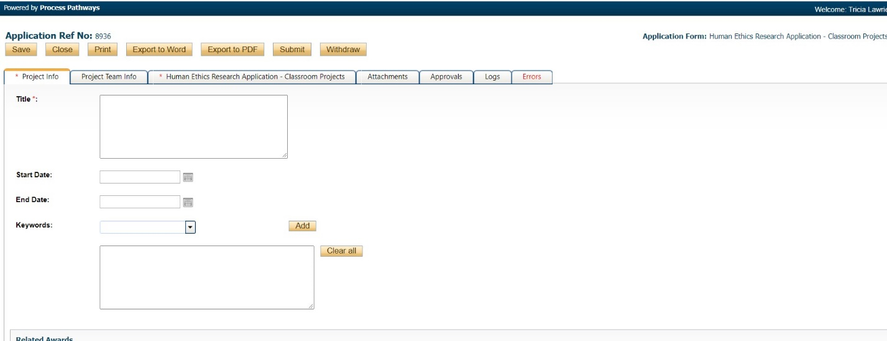

- If you hold a grant or award for this project then enter that in the tab:
  - Project info tab – related awards section – click on the search button -- enter the six digit romeo file number for the award or one of the other search terms. Completing this will allow release of funds for projects that require ethics certification, an important step! 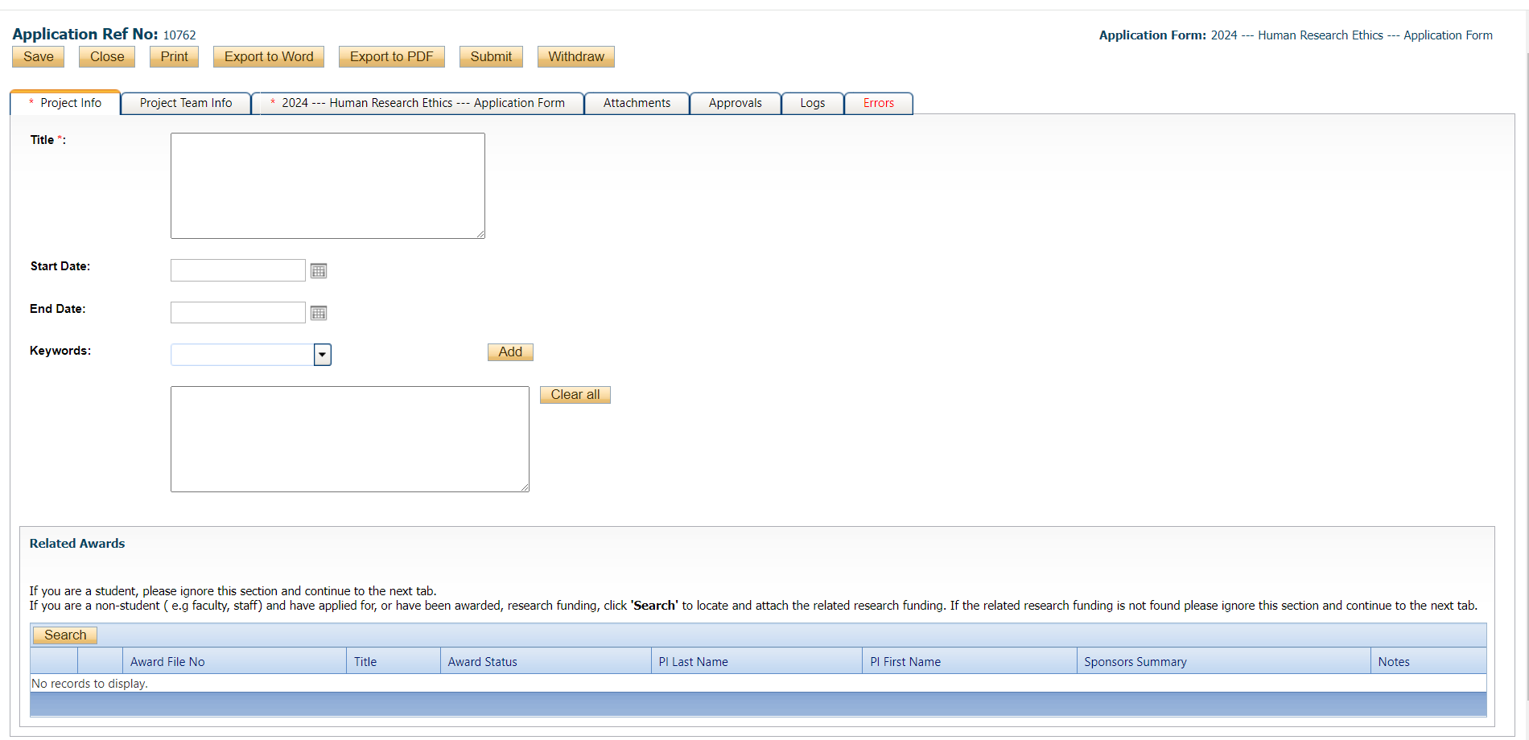
Here are some links to TRU supported tools for your data. They may or may not come in handy for your project. They are particularly relevant to the questions about data security that the REB ask:
- TRU survey monkey subscription through IT Services
- TRU data repository - Borealis through TRU library
- Data security tools through IT services
- sync.com alternative to drop-box that follows Canadian privacy laws through the Privacy and Access Office

- If you are a student, please ensure that your supervisor is added to the romeo file and has signed the Supervisor Declaration Form found on the webpage: supervisor declaration form. Below are the step by step instructions:
  - Your supervisor must have an account in Romeo. Click: Romeo Research Portal to create a romeo account
  - Add your supervisor to the tab called “Project Team Info”
    - Scroll to the very bottom of the tab “project team info”
    - Click “add new”
    - Search their name
    - Click “select” and “save”

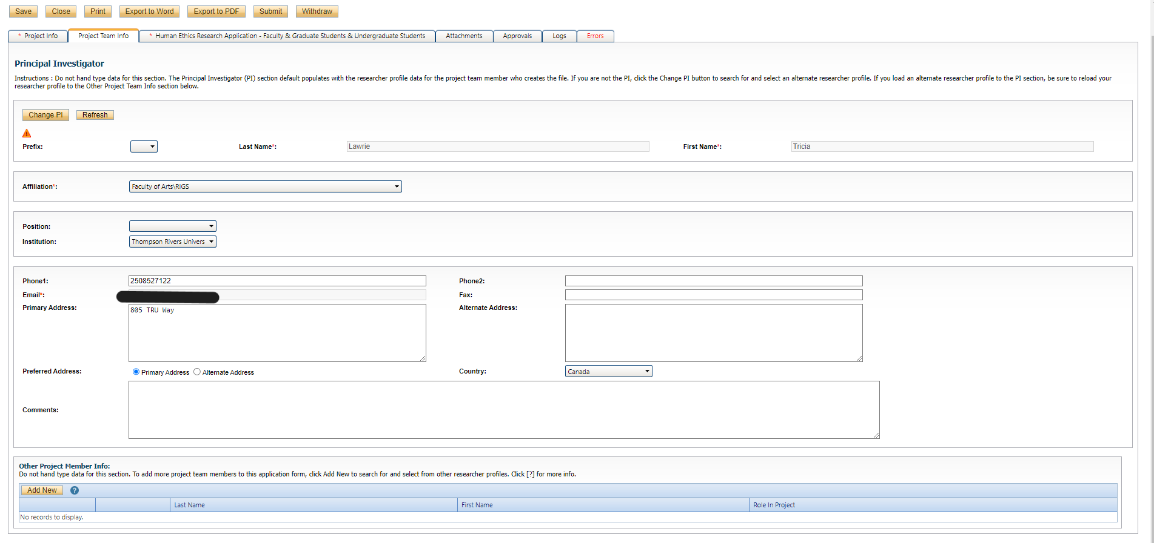
Students must have a supervisor to conduct research at university. The REB can review forms only after the supervisor is entered as project personnel and have attached the signed declaration form that states they have read and approved the REB application.

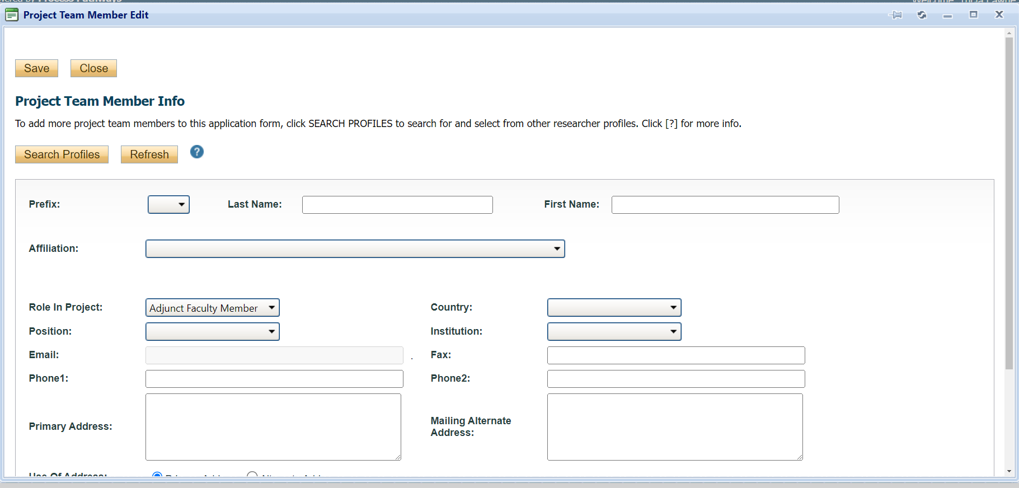

- Click “SUBMIT”
please note that only the Principal Investigator (PI) will have a submit button available on their screen. This is to ensure that only the PI can submit an application and/or changes to an application. This is because the PI is responsible for the ethics of the research protocol. Other project personnel including students can edit a file. But only the person with the oversight can submit, which in Romeo is a form of approval and verification.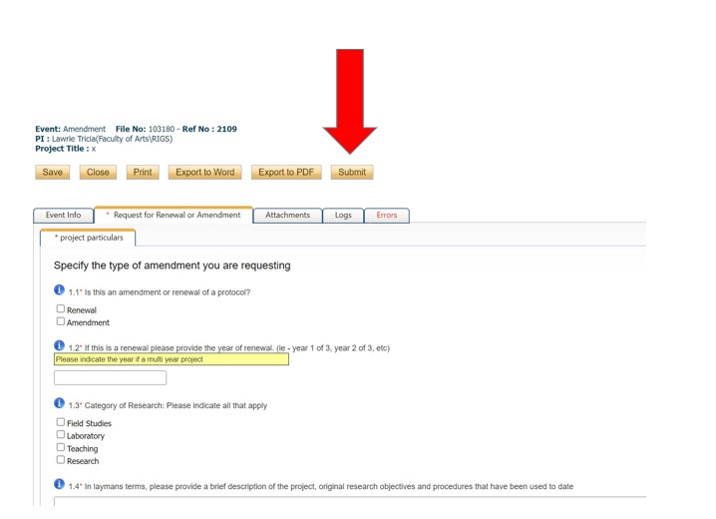

- ROMEO will require that you comment before you can submit. Unless you have something to say, anything will do. I usually just enter

Congratulations! You have successfully submitted your REB application. The REBs goal is to have feedback to you in four weeks. Then you can revise and resubmit your application based on that feedback. Then the REB will review your revisions. If outstanding items remain then the REB will address those with you again, until your application is finally approved.
Please feel free to contact me with any questions or concerns. TRU-REB@tru.ca. 250-852-7122.
~Tricia

