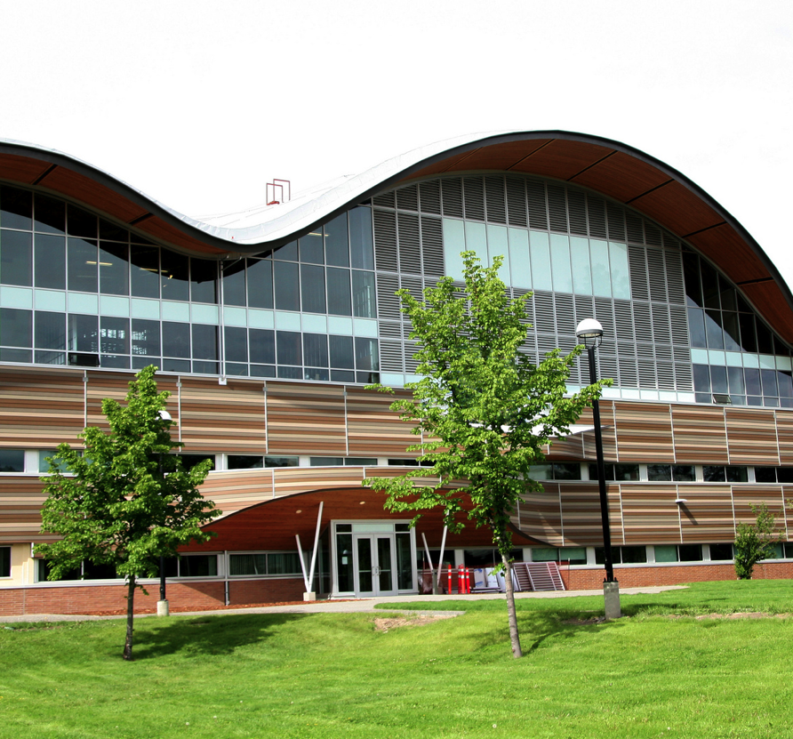

Table of Contents

Prepared By James Gudjonson Senior Management Support: __________________________
_ September 2013
__________________________

___________________________

Strategic Energy
Management Plan
2013

TRU Strategic Energy Management Plan

Section1- Institute Profile 4
1.1 Key Personnel 4
1.2 Institute Survey 4
1.2.1 Facility Profile 5
Background Description 7
1.2.2 General 7
1.2.3 Facility Components 7
1.2.4 Energy/Utility Supply 8
1.2.5 Energy Metrics/Key Performance indicators 8
Section 2: Energy Management Policy 10
2.1 Commitment by Institute 10
2.2 Energy Management Objectives 11
2.3 Energy Management Targets/Budget (2012-2015) 11
2.4.1 Key Personnel 13
2.4.2 External/Internal Stakeholders 13
Section 3: Energy Use and Costs.............................................................................................16
3.1 Energy Consumption and Costs 15
3.2 Greenhouse Gas Information 19
Section 4: Energy Management Projects and Actions 21
4.1 Past and Currently Undergoing Projects and Actions 21
4.1.1 Completed Energy Conservation Projects(2010) 21
4.1.2 Completed Energy Conservation Projects (2010-2011) Error! Bookmark not defined.
4.1.2 Completed Renewable Energy Projects 23
4.1.2 Energy Projects 2012-2013 Error! Bookmark not defined.
4.2 Proposed Projects 2013-2018 23
4.2.3 Summary of energy/cost savings and cost avoidance 24
4.3 Training, Communication and Awareness Programs 24
Appendix A, B, C ................................................................................................................26-29

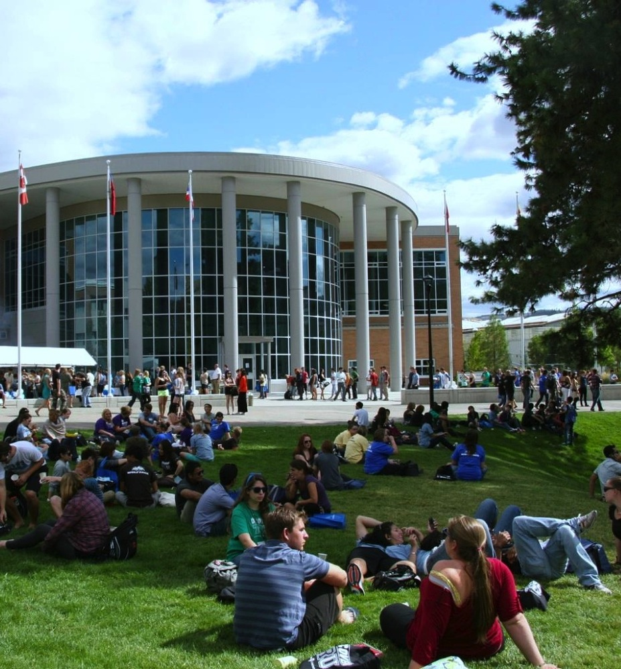

TRU Strategic Energy Management Plan

Section 1

Institution/Facility Profile

Section1- Institute Profile

TRU Strategic Energy Management Plan

Institute Name: Thompson Rivers University
Address: 900 McGill Road
Kamloops, British Columbia
V2C 5N3
Tel: (250) 828-5000
Fax: (250) 828-5086

  - Key Personnel

Key Executive: Matt Milovick

Telephone 250- 828-5011

Key contact: James Gudjonson

Telephone: (250) 852-7253

  - Institute Survey

Date Institute Formed: 1970

Total Area (m²): 92,173.19
Number of Campuses: 2
Name of Campuses Kamloops (29)
(#of Buildings): Williams Lake (1)

Number of Employees: 1725

Number of Students (on campus): 13,170

Title: VP Administration & Finance

E-mail: mmilovick@tru.ca

Title: Interim Director, Office of Environment & Sustainability

E-mail: jgudjonson@tru.ca

Institute Fiscal Year Dates: April 1-March 31
% Total Area heated: 98%
Number of Buildings: 30
Number of Buildings <10 years old: 6
Number of Buildings 10-25 years old: 7
Number of Buildings 25-40 years old: 9
Number of Buildings over 40 years old: 8

Number of Full Time Students: 6, 411
Number of Part Time Students: 6, 661
Full Time Equivalents (FTE):

TRU Strategic Energy Management Plan
    - Facility Profile

Primary Facility Profile
Building Code | Building Name | Year Built | Size  (m²) | Additions  (size/year) |  | BEPI  (KWhs/per sqf)
AE | Arts and Education | 1991 | 5,661.62 |  |  | 14.52
AHT | Animal Health Technology | 2002 | 1,180.66 |  |  | 12.51
CAC | Campus Activity Centre | 1992 | 6,413.48 | 500/2012 |  | 21.27
CT | Clock Tower | 1990 | 2,976.30 |  |  | 10
G | Gymnasium | 1980 | 3,703.59 |  |  | 10.64
IB | International Building | 2005 | 4,586.69 |  |  | 15.05
HOL | House of Learning | 2011 | 6,552.7 |  |  | 14.28
LIB | Library | 1975 | 3,350.64 |  |  | 8.75
OM | Old Main | 1970 | 19,814.14 | 4500/2013 |  | 11.93
S | Science | 1980 | 10,326.14 |  |  | 10.07
TT | Trades and Technology | 1997 | 10,326.46 |  |  | 8.2
TOTAL AREA- average BEPI |  |  | 79892.42 | 5000 |  | AVG = 12.5

Table 1. Summary of Primary Facilities

For campus map see appendix A, page 23

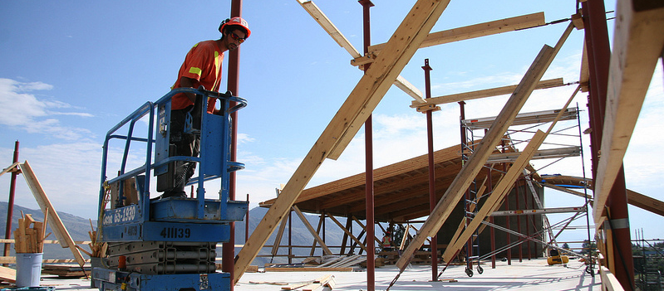

TRU Strategic Energy Management Plan
Secondary Facility Profile
Building Code | Building Name | Year Built | Size  (m²) | BEPI
BCCOL | BC Centre for Online Learning | 2007 | 4,334.81 | 28.83
CATC | Culinary Arts | 1970 | 1,858.87 | 22.9
CS | Chemical Storage | 1970 | 34.80
DAY | Daycare | 1993 | 441.90
ED | Electrical Distribution Shed | 1970 | 147.50
FAA*** | Faculty Annex A | 1971 | ***571.33
FB | Facilities Annex | 1973 | 92.02
FSS | Human Resources | 1970 | *543.56
H01 | House 1- Faculty Association | 1945 | 128.90
H02 | House2- OMEGA Student Newspaper | 1945 | ***138.60
H04*** | House4- | 1945 | 134.20
H05* | House 5- Aboriginal Cultural Centre | 1945 | 138.50
H06* | House 6- Research Centre | 1945 | 161.00
H07* | House 7- Research Centre | 1945 | 175.50
H08* | House 8- Radio Station | 1945 | 130.80
H09* | House 9- Foundation/ Alumni | 1945 | 267.18
H10* | House 10- Horticulture | 1945 | *346.39
HS* | Horticulture | 1985 | *326.90
MDC | Materials Distribution Centre | 2006 | 1,689.94 | 10.09
TTO | Trades Storage (no heating) | 1997 | 1,184.00
WS | Weather Station | 2005 | 144.00
BEPI | Average- secondary buildings (EkWh/per sqf) |  | **40.23
TOTAL AREA |  |  | 11,348.16
Table 2. Summary of Secondary Facilities
* Indicates meter has been recently installed or scheduled to be installed and BEPI will be established 2013 (meter data will be obtained through Pulse EMS system in summer 2013)
** Some buildings smaller than 1000 m² will not be sub-metered and will have an averaged BEPI
*** Buildings have been decommissioned
NOTE- BCCOL, CAC and CATC, the 3 buildings with the worst BEPI will be the focus of energy reduction projects for 2102-2013

Background Description

TRU Strategic Energy Management Plan

    - General

TRU has two main campuses. The primary campus is located at 900 McGill Road, Kamloops. The secondary campus is located at Western Avenue, Williams Lake. There are also several minor regional campuses at Clearwater, Barrier, Lillooet, and Ashcroft.

    - Facility Components

Lighting and Electrical Systems:
Interior lighting in the campus is primarily provided by fluorescent luminaries. Typically, buildings have utilized 34 W T12 lamps, which are now being replaced by 32 W T8 lamps. The T12 lamps are currently run by a mixture of standard efficiency and energy saving electromagnetic ballasts, and T8 lamps are run primarily by standard efficiency instant start electronic ballasts. The majority of interior lighting is manually turned on and off.

Fluorescent luminaries are complemented by incandescent and compact fluorescent lights. The Campus Activity Centre’s lighting is also supplemented by neon tube lighting in the high ceiling atrium and for signage.

Exterior lighting is provided mainly by High Intensity Discharge (HID) lighting, primarily High Pressure Sodium. Exterior lighting is largely controlled by photocells, and operates an average of twelve hours per day throughout the year. HIDs are also used in high ceiling areas such as the Library atrium, Trades building workshops and the Gymnasium, but these are mostly Metal Halide lamps.

Exit signs across campus are largely utilizing LED lamps, but a few use incandescent lamps, and must be replaced.

HVAC Systems:
Each building has an independent heating system that uses natural gas. Heating equipment varies in efficiency and age throughout the campus. Cooling is supplied by electric powered chillers and air conditioners (smaller buildings). A complete list of HVAC equipment is available in a central database.

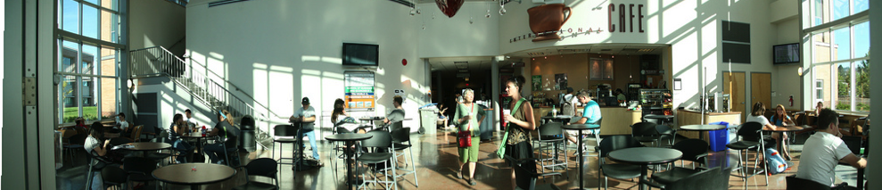

    - Energy/Utility Supply

TRU Strategic Energy Management Plan

- Electricity for the institute is supplied through one account by BC Hydro at rate 1211.
Utility | Vendor | Rate | In effect | Marginal Electricity ($/kWh) | Marginal Demand  ($/kW)
Electricity | BC Hydro | 1211 | April 2010-2013 | $0.0426 | $8.66
Electricity | BC Hydro | 1211 | January 2011 | Conservation Rate $0.068 | $8.66
Table 3. Rates Used for Electricity Savings Estimates (Not Including HST)

- Natural gas is provided by Fortis BC also through one account at rate 5.

Utility | Source | Rate | In effect | ($/GJ)
Natural Gas | Fortis BC | 5 | July 1, 2012 | $7.50
Carbon Tax | BC Government | na | 2010-2012 average | $1.50
Carbon Offset | BC Government | na | January 2011 | $1.25
Total |  |  |  | $10.25
Table 4. Rates used for Gas Savings Estimates (Not Including HST)

    - Energy Metrics/Key Performance indicators

- A Building Energy Performance Index (BEPI) has been established for all buildings > than 1000 m^{2 –} Several buildings smaller than 1000 m² are scheduled to have meters installed and a BEPI by February 2013. Pulse software will allow for BEPI reports for 22 buildings (to be done monthly).

- An averaged BEPI has also been established for all (occupied) buildings on campus. The averaged BEPI will allow TRU to compare with other institutions (see figure 5, p.16). In addition the averaged BEPI will also factor in expansion and new buildings. New buildings will also be sub-metered to allow for comparison between buildings on campus

- A Student Energy Metric (SEM) has also been established. This metric allows for comparing energy usage relative to student hours during summer, fall and winter semesters. This is important information for institution planners as well as providing a metric that resonates with administration staff, for example; students during the summer months use 6 times the electrical energy (and cost) per hour compared with students in the fall due to less students + cooling loads occupying same space.

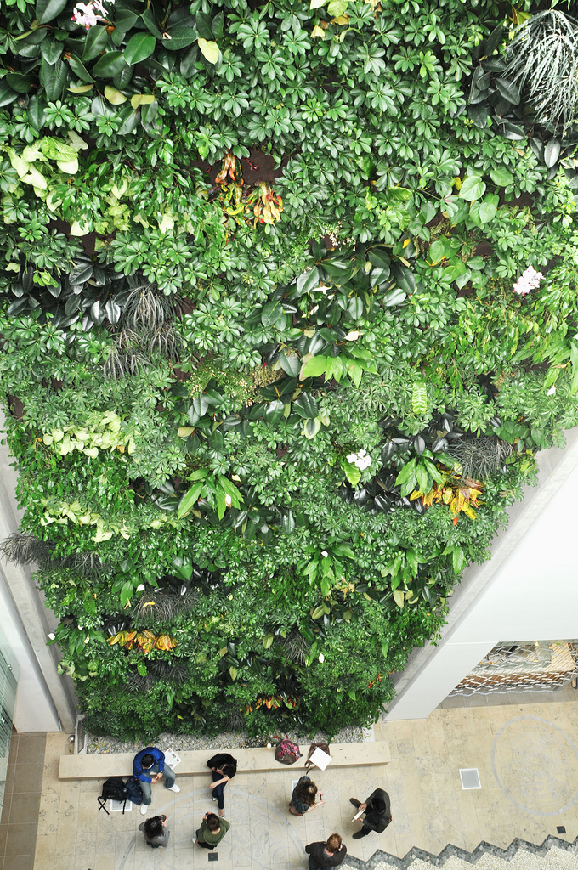

TRU Strategic Energy Management Plan

Energy Management Policy
Section 2

Section 2: Energy Management Policy

TRU Strategic Energy Management Plan
2.1 Commitment by Institute

One of Thompson Rivers University’s seven founding principles is to be the University of Choice for Environmental Sustainability. According to TRU’s Strategic Plan, TRU is committed to:
- Develop and expand programming and associated research activities in the areas of environmentally sustainable technologies, policy development, and environmentally and socially responsible economic development.

- Develop policies and best practices that support environmental stewardship and sustainability in the university’s operations.

- Foster environmental literacy amongst students, staff, faculty and alumni, and cooperate with other community partners to increase environmental awareness.

- Encourage the development of partnerships with public and private sector organizations in support of environmental stewardship and sustainability.

In April of 2010 the president of TRU signed the Talloires Declaration (TD), which has been signed by over 350 university presidents and chancellors in over 40 countries. Originally composed in 1990 at an international conference in Talloires, France, this is the first official statement made by university administrators of a commitment to environmental sustainability in higher education. The Talloires Declaration is a ten-point action plan for incorporating sustainability and environmental literacy in teaching, research, operations and outreach at colleges and universities.

http://www.ulsf.org/programs_talloires.html

For TRU’s sustainability policy see appendix B, page 24
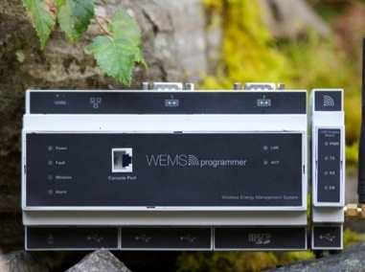
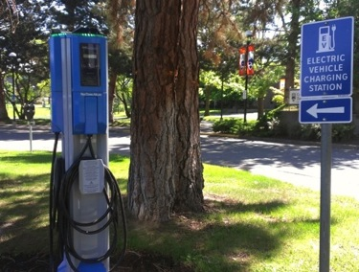

TRU Strategic Energy Management Plan
2.2 Energy Management Objectives

TRU‘s commitment to effective energy management is guided by the following objectives:

- To reduce energy usage, greenhouse gas emissions and operating costs through a comprehensive energy management program.
- To reduce energy usage, greenhouse gas emissions and operating costs by implementing and improving upon:
- Sound operating and maintenance practices
- Institution wide “green” purchasing policies
- Incorporating energy efficiency into all new building designs
- Utilizing an effective monitoring and tracking system
- To reduce energy usage, greenhouse gas emissions and operating costs by implementing an effective behavioral change program.
2.3 Energy Management Targets/Budget (2012-2015)

The first year of energy management objectives included a Detailed Energy Audit (DEA) of the primary buildings on campus, and a preliminary energy audit of the secondary buildings. The results of the DEA indicated TRU`s commitment to a 10 % reduction target in electrical and gas consumption was a realistic target for 2010-2011. The energy conservation project was completed in July of 2011 and the initial M&V reports indicate an 11-12% reduction was achieved.
The TRU energy reduction target for the period 2012-2016 is to achieve is an addition ~14% for a total reduction of 25% below baseline from 2010-2016.

Targets

Year | Reduction | Projects
2012-2013 | 6.6 % = 1 GWh | See table 4.1.2
2014 | 3.6% = .55 GWh | See table 4.1.3
2015 | 4% = .6 GWh | See table 4.1.3
2012-2015 (total) | 14.2% | See tables 4.1.2- 4.1.3

TRU Strategic Energy Management Plan
Targets
Budgets

Department | Dates | Budget
Environment & Sustainability- Energy projects | 2012 | $170,000 (projects completed)
Environment & Sustainability – Operating | 2103 | $300,000
Environment & Sustainability – Energy Projects | 2013 | $200,000 (not including VDI transfer project)
Environment & Sustainability – Energy Projects | *2014 (yearly base- energy revolving fund) | $200,000
Facilities | 2013 | 5.1 million
Maintenance | 2013 | 2.4 million

*Revolving fund established in 2012 from savings generated after original retro-fit project, fund will top out at $200,000K

TRU Strategic Energy Management Plan

2.4.1 Key Personnel

Planning Team
Name | Title | Roles/Responsibility
Matt Milovick | VP Finance/Administration | Executive sponsor
James Gudjonson | Director (interim) Office of Environment & Sustainability | Energy Champion, Energy Manager
Les Tabata | Director, Facilities | Organization of in house staff and resources
Lincoln Chua | Manager, Facilities | Organization of electrical, HVAC technicians
Natalie Yao | Energy Specialist | Implement energy projects
Environment Advisory Committee | Energy Sub-committee- Revolving Fund | Review and evaluate energy projects funded through revolving fund
Table 5.a. Planning Team Description

2.4.2 External/Internal Stakeholders

Name | Title/Organization | Roles/Responsibility
Students | Student Environmental Advisory Group | Promote ongoing sustainability awareness campaign
Faculty/staff | Environmental Advisory Committee | Draft/present sustainability policy to board of governors
City/greater community | City of Kamloops | Work together towards energy reductions (district energy talks, waste heat recovery, transportation issues for students/staff)
BC Hydro Power Smart staff | BC Hydro | Provide support/resources to help TRU reduce energy
Climate Action Secretariat | BC Government | Draft policies, provide support to public sector to promote reduction in GHG emissions
Table 5. b. Stakeholders Description

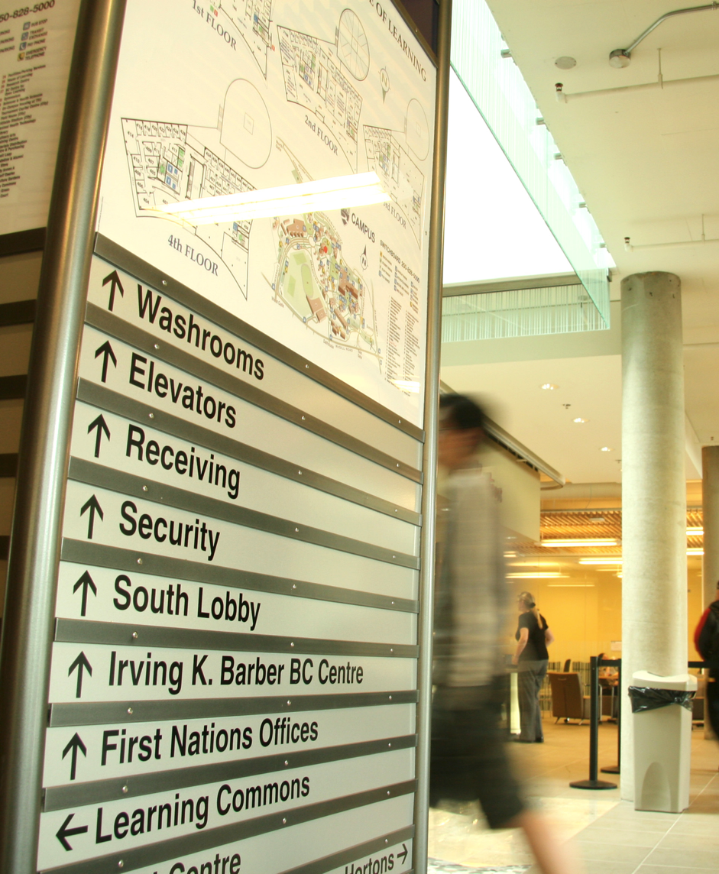

TRU Strategic Energy Management Plan

Section 3

Energy Use and Costs

TRU Strategic Energy Management Plan
Section 3- Energy Use and Costs
3.1 Energy Consumption

Table 6a. Comparison of Annual Energy Use with and without Energy Management Program (EKWh)

Table 6b. Moving Forward – Projected savings/Impacts of 25% Reduction Target

Table 6c. Building Energy Performance Index (BEPI) (2013-2015 Projected)

TRU Strategic Energy Management Plan

TRU Strategic Energy Management Plan
Figure 1. Breakdown of Institute Energy Use

Figure 2. Breakdown of Institute Energy Use Costs

Figure 3. Energy Performance Comparisons for Five Colleges/ Universities in BC

TRU Strategic Energy Management Plan
Average: 32.6

TRU Strategic Energy Management Plan
3.2 Greenhouse Gas Information

Table 7. Summary of Annual Greenhouse Gas Emissions
Annual Greenhouse Gas Emissions
 | Electrical |  |  | Fuel |  |  | Total
Year | kWh | e kWh | GHG (tonnes) | GJ | e kWh | GHG  (tonnes) | e kWh | GHG (Tonnes)
2007 | 15,104,403 | 15,104,403 | 347.4 | 69,384 | 19,273,195 | 3,459.8 | 34,377,598 | 3,807.2
2008 | 15,283,229 | 15,283,229 | 427.9 | 71,706 | 19,918,306 | 3,575.6 | 35,201,535 | 4,003.5
2009 | 15,367,200 | 15,367,200 | 430.3 | 68,832 | 19,120,111 | 3,432.3 | 34,487,312 | 3,862.6
2010 | 16,058,604 | 16,058,604 | 400.43 | 67,140 | 18,650,108 | 3377.17 | 34,708,712 | 3,777.6
2011 | 15,026,400 | 15,026,400 | 370.17 | 66,497 | 18,471,388 | 3,335.49 | 33,497,788 | 3,706
2012 | 15,254,565 | 15,254,565 | 378.93 | 61,028 | 16,952,222 | 3,061.16 | 32,206,787 | 3,440

Figure 4. Breakdown of the Institute’s Greenhouse Gas Generation

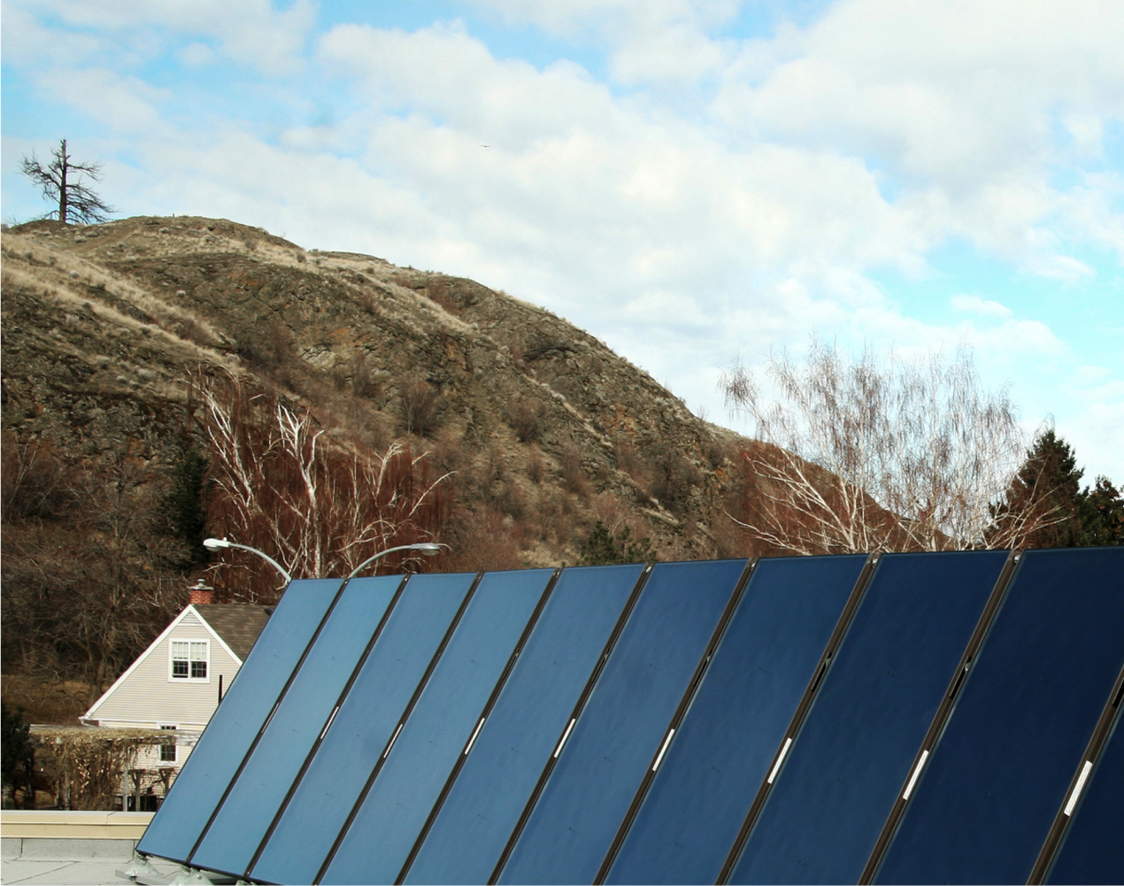

TRU Strategic Energy Management Plan

Section 4

Energy Management
Projects & Actions

TRU Strategic Energy Management Plan

Section 4- Energy Management Projects and Actions
Past and Currently Undergoing Projects and Actions

    - Completed Energy Conservation Projects (2010-2011)
2010 Projects
Measure | Demand Savings (kW) |  | Electrical Savings (kWh) | Electrical Savings ($) | Fuel Savings (GJ) |  | Fuel Savings ($) | Total Cost Savings ($) | Incentive  Savings  ($) |  | Budget Retrofit Costs | Simple Payback (yrs)
A/E T12 Replacement |  |  | 3660 | 2400 |  |  |  | $2,400 |  |  |  | 8
Replace power bars with smart bars |  |  | 140,000 | 6300 |  |  |  | $6,300 | $7,000 |  | $13,000 | 2
TOTAL 2010 | - |  | 143,360 | $8,700 | - |  | - | $8,700 | - |  | - | -
2011 Projects
Measure |  | Demand Savings (kW) | Electrical Savings (kWh) | Electrical Savings ($) | Fuel Savings (GJ) |  | Fuel Savings ($) | Total Cost Savings ($) | Incentive  Savings  ($) |  | Budget Retrofit Costs | Simple Payback (yrs)
ECM 1: Lighting Base Retrofit |  | 189.9 | 678, 802 | $46,656 | - |  | - | $45,628 |  |  | $657,550 | 14.2
ECM 1: Lighting Screw-in CF Retrofit |  | 4.5 | 14, 762 | $46,656 | - |  | - | $1,028 |  |  | $3,450 | 14.2
ECM 2: Lighting Controls |  | - | 122,292 | $4,941 | - |  | - | $4,941 |  |  | $65,500 | 13.3
ECM 3: Vending Machine Usage Control |  | - | 45,033 | $1,819 | - |  | - | $1,819 |  |  | $10,000 | 5.5
ECM 4: Appliance Timers for Corridor Televisions |  | - | 10,530 | $425 | - |  | - | $425 |  |  | $650 | 1.5
ECM 5: Power Factor Correction |  | - | 0 | $8,191 | - |  | - | $8,191 |  |  | $36,800 | 4.5
ECM 6: Holiday Scheduling |  | - | 198,380 | $8,015 | 768 |  | $6,960 | $14,975 |  |  | $31,000 | 2.1
ECM 7: Optimum Start Morning Warm-up and Cool down for Ventilation Systems |  | - | 216,990 | $8,765 | 839 |  | $7,600 | $16,365 |  |  | $44,900 | 2.7
ECM 8: Summer Scheduling |  | - | 67,345 | $2,720 | 0 |  | $0 | $2,720 |  |  | $6,500 | 2.4
ECM 9: VAV Zone Isolation |  | - | 116,330 | $4,700 | 203 |  | $1,845 | $6,545 |  |  | $50,000 | 7.6
ECM 10: DCV for Classrooms and Offices Served by WS Heat Pumps |  | - | 21,755 | $880 | 1,227 |  | $11,125 | $12,005 |  |  | $102,500 | 8.5
ECM 11: Demand Controlled Ventilation for Clock Tower Theatre |  | - | 3,800 | $155 | 23 |  | $210 | $365 |  |  | $3,900 | 10.7
ECM 12: Align Clock Tower DDC Weekly Schedules with Typical Occupancy |  | - | 3,295 | $135 | 140 |  | $1,265 | $1,400 |  |  | $8,700 | 6.2
ECM 13: Trades Welding Booth Fan Operation |  | - | 36,120 | $1,460 | 851 |  | $7,710 | $9,170 |  |  | $40,200 | 4.4
ECM 14: Wood Shop Dust Collector Occupancy Controlled Shutdown |  | - | 9,885 | $400 | 14 |  | $130 | $530 |  |  | $5,200 | 9.8
ECM 15: Standby Mode and DCV for Gym Ventilation Systems |  | - | 30,050 | $1,215 | 330 |  | $2,985 | $4,200 |  |  | $12,900 | 3.1
ECM 16: Heat Pump Loop Pump Shutdown |  | - | 33,815 | $1,365 | 0 |  | $0 | $1,365 |  |  | $8,300 | 6.1
ECM 17:Old Main Unoccupied Exhaust Fan Shutdown |  | - | 7,910 | $320 | 365 |  | $3,300 | $3,620 |  |  | $27,100 | 7.5
ECM 18: Install Flue Dampers on CAC Heating Plant |  | - | 0 | $0 | 1,377 |  | $12,480 | $12,480 |  |  | $8,000 | 0.6
TOTAL 2011 |  | 194.4 | 1,617,095 | $92,160 | *6,135 |  | $55,613 | $147,775 |  |  | $1,123,150 | 7.6
2012 Projects
COP (BCCOL) |  |  | 110,000 | $8800 |  | 600 | $4150 | $12950 |  | n/a | $16,000 | 1.5
Demand Ventilation Controls CATC |  |  | 50,000 | $4250 |  | 650 | $3925 | $8175 |  | $5000 | $18,680 | 2.5
Demand Ventilation Controls CAC |  |  | 50,000 | $4250 |  | 500 | $3250 | $7500 |  | $5000 | $16,000 | 2.5
WEMS (CATC) |  |  | 100,00 | $8500 |  | n/a | $ | $8500 |  | $80,000 | $97,000 | < 2
WEMS (Library) |  |  | 30,000 | $2550 |  | n/a |  | $2250 |  | *(above) | *(above | *(above)
TOTAL 2012 |  |  | 340,000 | $28,050 |  | 1,750 | $11,325 | $39,375 |  | $100,000 | $145,680 | 1.3
2009 Data for Entire Campus |  | - | 15,367,200 | $852,349 |  | 68,832 | $559,001 | $1,411,350 |  |  | - | -
% Savings |  | - | 12.7% | 14% |  | 11% | 10% | 10% |  |  | - | -
TOTAL  To-Date |  |  | 1,957,095 | $120,210.00 |  | *7885 | *$66,938 | $187,148.00
*Final fuel savings to be modified
* WEMS project costs and savings includes CATC and Library buildings

4.1.2 Completed Renewable Energy Projects

TRU Strategic Energy Management Plan

Table 8. Summary of Measures for New Building Additions
Section | Measure | Electrical Savings (kWh) | Electrical Savings ($) | Fuel Savings (GJ) | Fuel Savings ($) | Total Cost Savings ($) | Incentive Savings ($) | Budget Retrofit Costs ($) | Simple Payback
 | **Solar DHW- OM |  |  | 800 |  |  |  | 72,000 | 0
 | **Solar DHW- CAC |  |  | 600 |  |  |  | 108,000 | 0
 | **Solar DHW- CATC |  |  | 465 |  |  |  | 82,000 | 0

4.2 Proposed Projects 2013-2018

Table 9. Summary of Projects 2012-2015
2013 Projects
Measure | Electrical Savings (kWh) | Electrical Savings ($) | Fuel Savings (GJ) | Fuel Savings ($) | Total Cost Savings ($) | Incentive Savings ($) | Budget Retrofit Costs ($) | Simple Payback
Residence Sensors | 200,000
IT- Change to VDI | 250,000
COP (A&E) | 82,490 | 7,235 | 211 | 1,795 | 9,030 | TBD | 22,100 | 2.6
COP (IB) | 76,997 | 6,753 | 23 | 193 | 6,946 | TBD | 19,400 | 3.1
COP (CAC) | 28,902 | 2,535 | 1,016 | 8,634 | 11,169 | TBD | 21,200 | 1.9
COP (S) | 40,848 | 3,583 | 254 | 2,161 | 5,744 | TBD | 26,400 | 5.5
COP (T&T) | 25,157 | 2,206 | 183 | 1,555 | 3,762 | TBD | 18,000 | 5.7
2014 Projects
Measure | Electrical Savings (kWh) | Electrical Savings ($) | Fuel Savings (GJ) | Fuel Savings ($) | Total Cost Savings ($) | Incentive Savings ($) | Budget Retrofit Costs ($) | Simple Payback
COP (HOL)-2014 | TBD | TBD | TBD | TBD | TBD | TBD | TBD | 2
COP (OM)-2015 | TBD | TBD | TBD | TBD | TBD | TBD | TBD | 2
IT-Change to VDI | 250,000 | $59,5000 |  |  |  | $59,500 | TBD | TBD
Behaviour Change | 100,000
Residence sensors | 100,000 | $8500 |  | 27,153 | 32,153.79 | TBD | 93,112.39 | 3
2015 Projects
Measure | Electrical Savings (kWh) | Electrical Savings ($) | Fuel Savings (GJ) | Fuel Savings ($) | Total Cost Savings ($) | Incentive Savings ($) | Budget Retrofit Costs ($) | Simple Payback
Behaviour Change | 100,000 | TBD | TBD | TBD | TBD | TBD | TBD | 0
Total (estimated) | 1.6 GWh | 85,000 | 5000 | 50000 | 135,000 | TBD | 220,000 | 2 years
* The electrical savings and incentive savings are only based on replacing 4’ T12
lamps with T8 lamps and electronic ballasts
** This is a combination of the electrical savings ($4014) and maintenance savings ($1297)
calculated by the BC Hydro Calculator

4.2.3 Summary of energy/cost savings and cost avoidance

TRU Strategic Energy Management Plan

Table 10. Summary of Planned Measures for Secondary Projects
Year | KWhs saved | Fuel Savings (GJ) | Cost Savings ($) | Avoided cost | Total Dollars saved
2010 | 143,660 |  | $8700 | $1356 | $10,056
2011 | 1,665,095 | 6000 | $203,690.20 | $24022 | $236412.2
2012 | 300,000 | 1000 | $34,000 | $1200 | $35200
To Date | 2,108,755 | 7000 | $2246390.20 | $26,578 | $272968.20

4.3 Training, Communication and Awareness Programs
Program | Anticipated Savings (KWH) | Target Audience | Estimated Reach  (# people) | Start/End Date
Home/Work Challenge | TBD | Staff and Faculty | >100 | Fall 2011- ongoing
BuiltSpace | TBD | Staff and Faculty | 500 | 2012- ongoing
Media Campaign | TBD | Staff, Faculty, Students | 15,000 | 2103-2104
Yearly Initiatives
 | Anticipated Savings (KWH) | Target Audience | Estimated Reach  (# people) |  | Start/End Date
Earth Hour |  | Staff, Faculty, Students | 15,000 |  | Annual
Sweater Day |  | Staff, Faculty, Students | 15,000 |  | Annual
A successful training, communication and awareness program is an integral part of TRU`s energy management plan. The following is a description of ongoing and future strategies:

Training
- Staff training for all new energy related equipment (smart bars, multi-function copiers etc.)
- Technical staff engagement and training for all retrofit and new building projects involving new equipment and controls
- Staff training for new scheduling and zone isolation energy conservation measures scheduled for winter 2010-2011(knowing where override buttons are etc.)
- Utilize Trade & Technologies Department faculty and Trades students to help with retrofit project, and turn campus into ‘living lab’

Communication and awareness
- Maintain and update existing website to inform and engage entire TRU community in energy, sustainability and environmental related projects and initiatives. Comprehensive media campaign this fall to inform building occupants regarding energy efficiency upgrades in buildings and launch 25% reduction target media campaign. Utilize traditional and social media to increase social media profile
- Continue to engage in campus activities to inform students and staff of ongoing green projects and initiatives (kiosks, handouts, posters etc.)

- Appendix A

TRU Strategic Energy Management Plan

TRU Campus Map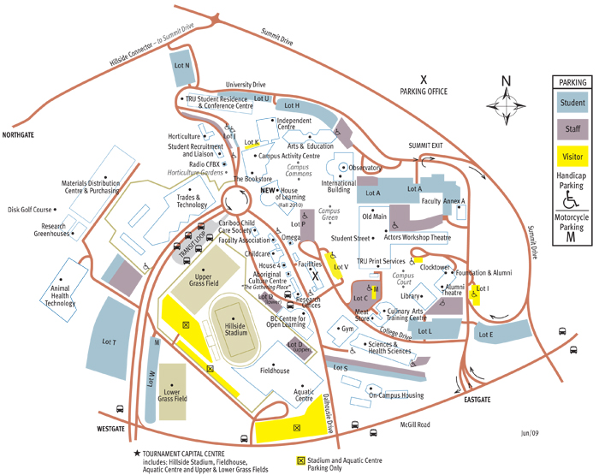

Primary Buildings

Secondary Buildings

Appendix B

TRU Strategic Energy Management Plan
TRU Sustainability Policy

POLICY
Thompson Rivers University recognizes that it has a significant role to play in education, research, policy development and information exchange related to the health of the local and global environments in which we live and work. TRU seeks to be the University of Choice for students concerned about environmental sustainability and to be recognized for its leadership and stewardship in responding to environmental challenges.

This policy should guide other operational policies and procedures that may be developed to demonstrate responsibility and due diligence on the part of the University and to educate and assist members of the University community to understand and fulfill their environmental and sustainable responsibilities
The University is committed to being the ‘University of Choice for Environment and Sustainability’ as set out in the Strategic Plan 2007-2012.
The University is a signatory to the Taillores Declaration and the University and College Presidents’ Climate Statement of Action for Canada.
This policy applies to all campuses and all activities of the University

REGULATIONS
Purpose
- To facilitate and support the University’s mission with respect to Environment and Sustainability as set out in the Strategic Plan.

- To establish appropriate standards for managing sustainability initiatives at the University

- To establish the process and responsibilities for standards measures and monitoring related managing sustainability initiatives at the University

- To outline the principles through which the environmental and sustainability objectives can be achieved.

- To outline the roles and responsibilities for implementing Sustainability Action Plans

TRU Strategic Energy Management Plan

Definitions
Sustainability
Meeting the needs of the current situation which does not compromise the needs of future generations through a decision making process which integrates ecological, economic and human factors.
Environment
Surrounding conditions, forces or influences which influence the natural, built, or human systems.

University Community
The University community includes the physical setting in which any University programme is delivered in Canada and internationally. It also includes all individuals which design, deliver, participate in and support the programmes which TRU delivers.

University Community
The university community includes the physical setting in which any TRU programme is delivered in Canada and internationally. It also includes all individuals who design, deliver, participate in and support the programmes which TRU delivers.

Principles
- Leadership in Sustainable Operations
  - TRU will maximise energy efficiency, use of renewable resources and use best available carbon reduction technology.
  - TRU will minimize water consumption, waste generation and the use of toxic substances in all campus operations. Where substitution, reuse or recycling cannot be implemented, best practices will be used in the disposal of the remaining waste
  - TRU’s procurement policy will integrate evaluation of social, ethical and economic factors in the purchasing process though the use of such tools as life cycle costing or similar analysis.

  - TRU will consider biodiversity in decision making regarding the use and development of campus lands

- Leadership in Evaluating Success

2.1 TRU will continually measure and monitor the impacts of its activities against the principles of sustainability, setting objectives and targets and measuring results in the form of a Campus Sustainability Action Plan which will be updated every three years with the first update to occur in parallel to the Strategic Plan 2007-1012 update.

- Leadership in Community Sustainability

3.1 TRU will foster and encourage the development of sustainable practices and activities among all faculty, staff, student and administrators of the institutions both on campus and in the broader community.

TRU Strategic Energy Management Plan
3.2 TRU will work cooperatively and provide support to sustainable programs and actions in the broader community both for its alumni and other organizations and individuals.

3.3 TRU will work with other universities, government departments and organizations to further the objectives of sustainability in society generally

- Leadership in managing Environmental Risks

  - The University, through the Office of Environmental Sustainability, will establish and manage an environmental management plan which sets targets, indicators and measures environmental performance and reports progress
  - The University commits to a process of continual environmental improvement and best practices

- Responsibilities for implementation
  - The Vice Presidents are responsible for reviewing the Environmental and Sustainability Action Plans for their portfolios, and for approving actions, schedules and funding to implement. Information from the Plans will be compiled and published in an Annual Environmental Sustainability Report
  - The Director of Environmental and Sustainability is responsible for coordination, advocacy and communication of the sustainability principles, objectives targets and activities on campus. The Director will also support TRU’s sustainability actions within the broader community, government departments and organizations and other universities.
  - The Director of Environment and Sustainability is responsible for regulatory reporting

TRU Strategic Energy Management Plan
APPENDIX C (BEPI)

